**Introduction**

A career in Information Technology (IT) can be defined as services and expertise provided to businesses and users *(Ubilla)*. These services and expertise are provided by professionals who often help companies upgrade their software and systems. According to the Occupational Outlook Handbook published by the Bureau of Labor Statistics, the information technology field is broken down further into scientists, architects, programmers, analysts, administrators, and developers *(BLS)*. Each occupation has the same goal, which is to solve complex computer problems for companies and organizations.

The IT field is expected to increase 25% in the total number of positions through the year 2020 *(BLS)*. The biggest growth sections of IT will be software developers, *systems analysts* and computer support specialists.

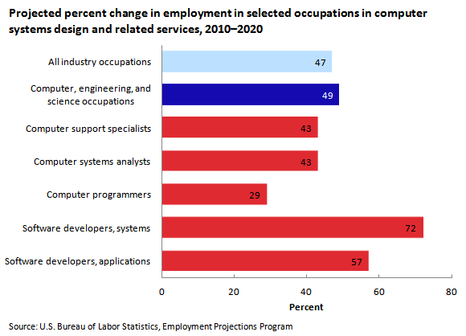

Figure 1: Anticipated Increase in Computer Systems Jobs

The boom in jobs is because companies are adopting the latest trends in technology, such as mobile computing, information security, and cloud computing. Google has changed their search algorithms and forced all businesses to now have mobile-friendly websites. Every business is concerned about data and how to protect it from data thieves and unscrupulous employees. Cloud computing has seen a tremendous growth as all companies are now using some type of cloud storage, server, or software as a service *(Ubilla)*. Each of these has increased- and will continue to increase- the job growth patterns over the next 10 years.

The purpose of this paper is to assess if a degree will provide happiness and career growth within the IT field. The information is based on research from government and education resources, as well as interviews conducted with these four professionals:

1. Sean Morris, a self-taught developer, who currently works for Martha Stewart Living OmniMedia. Sean has been in the field since 2008.
2. Robert Reynolds, who holds an associates degree from Nassau Community College, is a Vice President of Technology at ArkNet Media, a small media company in Garden City. He has been in the field since 2002.
3. Tony Leota, who holds a Masters Degree in Computer Science from Stony Brook University, has been working in IT since 1985 and currently holds the position of Lead Python Programmer at Bank of America.
4. Alex Pelaez holds a PhD from CUNY Graduate School, an MBA from Hofstra University, an MS in Computer Science from NYU, and a Bachelors degree from NYU.

The report covers these topics: what kind of knowledge is required to start a career in Information Technology, what kind of career growth is available within IT, what skills and experience are expected, and where the industry is headed in the next 5-10 years.

The report concludes by looking at the different levels of knowledge of each interviewee to determine if a degree necessarily results in an increase in job growth and happiness.

**Data Section**

**Job Requirements**

The career field of Information Technology is constantly evolving. Some of the job requirements of 5-10 years ago don’t even apply in today’s world. The most essential skill for anybody wanting to gain employment within the field is to stay current with the new trends as well as to master standard programming and logic skills *(DOL)*.

Here is a list of Job Requirements that were gathered from speaking with four IT professionals:

* Project Management
* Monitoring project deliverables and milestones
* Knowledge of servers, application software, and databases
* Understanding of business strategies and management
* Logic and reasoning abilities
* Speaking clearly and helping others understand
* Organization and the ability to plan and prioritize
* Decision making

Surprisingly absent from the job requirement list are the actual software skills and programming languages. While it is important to have a basic knowledge and understanding of syntax, each professional interviewed felt that if a candidate possessed a strong background in the skills above, he/she would be able to learn quickly from different programming environments. Martha Stewart Living encourages an agile software environment, which means that everybody meets as a team every morning and talks about the day’s projects and what they expect to accomplish. Arknet Media, a smaller development team than Martha Stewart, uses a development company in India, where most of the coding is completed overseas and then two in-house programmers assemble the code.

**Career Growth Ahead**

The Bureau of Labor Statistics reports that 1.5 million people were employed in IT in 2011 *(BLS)*. Most of the industry growth has happened under Computer Systems Designs. The largest areas of expected growth are related to the new mobile and cloud computing technologies *(BLS)*.

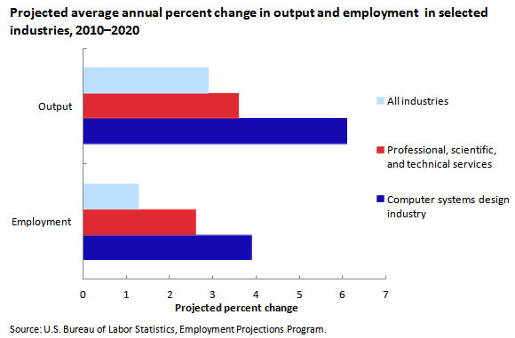

Figure 2: Project Employment in Computer Systems Design

Each of the interviewees had their own take on the latest trends. Robert and Sean both saw their companies moving fully into cloud computing. Each felt that this was where the industry was headed, while Tony, who works in a bank, had a much different view. He felt that the financial services industry had a different view on cloud computing because of security and data theft. Cloud computing in financial services was happening internally with very little third-party cloud computing on the horizon. As many other industries adopt the new technologies of cloud computing, the growth of jobs in cyber security will increase along with employment increases in both cloud and mobile computing.

**Skills and Experience**

The United States Department of Labor (DOL) recommends that all IT related employees should, at a minimum, have some type of certification *(DOL)*. The DOL also found that community college had been playing a unique role in the IT field by developing certificate- level training courses in order to retrain older adults and industry veterans wanting to learn new skills.

Problem solving and analytical skills are highly regarded skills for any IT professional. Most companies look for these skills during the hiring process through the use of puzzles and mind games to see how prospective employees can handle pressure and see how they think. Martha Stewart Living OmniMedia has now incorporated puzzles into their interview process, while Arknet Media uses a whiteboard and asks prospective employees to create a small program and write the algorithm on the board.

Troubleshooting and helping other employees are important parts of any IT related job. There is constant interaction between users, managers, and coworkers. Those interpersonal skills, once considered unessential, are now more important than ever. Effective communication and writing skills are a requirement in today’s business environment. Users need to have written documentation, as well as have special training on new systems.

Tony and Robert, who are both part of the hiring process in their companies, agreed that while there are many skills that look great on paper and in an interview, there are soft skills that are critical to being successful in the IT field. Communicating well developed thoughts, problem solving both internally and externally, and teamwork were the top skills their companies were seeking.

**The STEM Initiative - A Future Trend?**

Information technology falls under the STEM Initiative, which is a cause that has recently been picked up by the White House and Congress *(DOC)*. STEM stands for Science, Technology, Engineering and Mathematics. President Obama has presented a national strategy to increase the funds and education centered towards the explosive growth of STEM related jobs *(Senate)*, half of which are centered around Information Technology *(Senate)*.

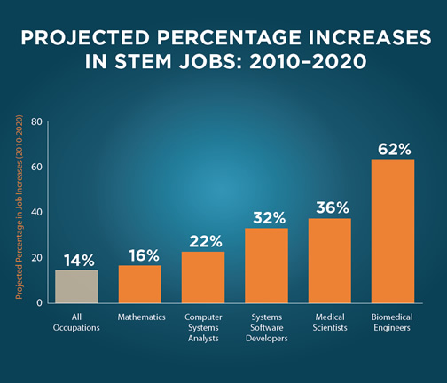

Figure 3: Project Increase in Computer Related Jobs

The 2015 budget proposed by President Obama includes $110 million dollars in grants to schools to develop and create new IT related programs *(DOE)*. Another $40 million dollars are in the form of grants to train and develop new teachers *(DOE)*. Alex Pelaez, an Information Technology professor at Hofstra University, had strong feelings towards the growth of teachers in the IT field. He has personally mentored a number of new hires at Hofstra within the IT department. Professor Pelaez has held the largest range of positions within the IT field. He started as a programmer and developer, who eventually worked his way up to VP of Technology at a large health care company. He felt that while he enjoyed what he did, he was not happy with corporate politics and decided to pursue teaching. He is now a professor and researcher within the field and felt that with the grants available, teachers and researchers of Information Technology related subjects would actually be one of the fastest growing sectors.

**Happiness and Job Satisfaction**

The IT field is driven by innovation and the ability to create new ideas. According to a study conducted by the U.S. Department of Commerce, IT employees had earnings that were 25% higher than non-IT employees *(Senate)*. The study also revealed that one third of all IT workers did not have a college degree *(Senate)*. Those with degrees in the IT field were more likely to have higher earnings than their counterparts. Individuals with a High school diploma or less were earning $25 per hour while one with a bachelors degree was earning $35 per hour.

Professor Pelaez, who holds the most degrees among the interviewees, loves his current job and felt it did make him happy and very satisfied. He said that teaching is a rewarding part of his job, but the part he enjoys most is the research that he conducts for Hofstra. Getting his work published about new technologies and web technology trends was what he enjoyed most. He said, “Seeing your name published in an industry article is the best feeling.” Professor Pelaez felt that working in corporate America provided a number of unnecessary pressures and stresses. A number of his former co-workers have left their corporate IT jobs and now work as freelancers and consultants.

Tony felt that a degree in the IT field, although not at all impactful on happiness, did have a major impact on the short term development of one’s career. Tony said that after an individual has been in the field long enough and had the ability to prove their knowledge and skill set through a project portfolio, they were able to advance within the field to project management and into executive management. Tony has worked at the most companies of the panel. He felt that job happiness was directly related to a person's own situation. Many of his degree holding former co-workers have now moved into upper management. The jobs these people now hold are paying two to three times what they were making when they started in the field and that the higher income is what has provided job happiness and security. He did agree that these people could not have made it to the positions that they currently hold without having a degree and established project portfolios.

Robert has the lowest degree among the panel, an associates. His degree is what led to him into the field. Robert agreed with Alex that while each company has its own degree of stress and pressure, he loved that part of the IT culture. Robert felt that it was very rewarding to build a company’s website, develop their strategy, and generate additional revenues. He has worked for both small and large companies and feels that his associates degree was a non-factor in getting his current position; it was his work experience and portfolio of past projects that got him hired. He is extremely happy in his current position and loves what he does. While he does not correlate an associates degree with job growth, he did state that it helped him get started and that he had to work harder than his peers who held bachelors degrees.

Sean has no degree. He began as a self-taught individual and is a strong believer that anybody with hard work and determination can be not only be happy but also successful in their IT career. Sean started reading programming and algorithm books in high school and taught himself both C and Pearl. The C language is the basic syntax that most programming languages are built on today. Pearl is a dynamic scripting language that is built on C and the UNIX operating system. Sean built his own project portfolio early on which helped start his young IT career. He started out working minimum wage as a developer, and eventually landed a full time developer position at Martha Stewart. Sean had to learn Drupal for his current position, which was a skill he did not possess. When asked why Martha Stewart Living hired him without knowing their in-house programming language, Sean said that Martha Stewart was looking for those soft skills, the intangibles that would make him a great developer on their staff. Sean is a clear example of an individual who has no degree, yet is extremely satisfied in his career and has experienced job growth based on career performance.

**Conclusion**

**Summary of Findings**

Information technology has some exciting job prospects for the next 5-10 years. It’s the type of field that has the potential to continuously grow as new technologies and innovations continue. While we may not see the flying car anytime soon, self-driving cars are definitely here and are led by innovations in IT.

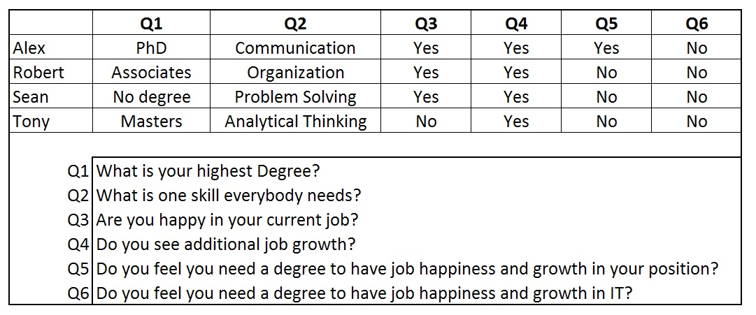

Table 1: Summary of General Questions

The most important fact that was uncovered from speaking to the IT professionals as well as the secondary research was the importance of soft skills. Knowledge of the basic foundations of how to program and develop was needed, but it was not a required skill. Every subject with whom I spoke felt that the syntax of each individual language was easy to grasp over the short term and can be easily learned on the job. It is the communication, problem solving, analytics, and organization skills that are most sought after during the hiring process.

**Interpretation of Findings**

From speaking with the four professionals, it is apparent that having a degree does not lead to any type of job happiness. The degree does have a short term effect on job growth, as it proved useful for Tony, Alex and Robert; conversely, Sean had to work harder for less pay to build up his project portfolio and then prove himself to prospective employers through his work experience.

**Recommendations**

In my recent experience, there is a disconnect between what is taught in the bachelors degree programs and what is expected in the IT workforce. While Farmingdale has a great regional program, there are a number of problems with what it offers vs. what employers expect. While the degree will gain students a foot in the door, it will not necessarily lead to job satisfaction and career growth.

* Universities and colleges that offer Information Technology programs need to create a program that incorporates the soft skills that employers are looking for.
* These new programs should integrate local, regional, and national industry professionals who have the real world experience that can shape the future IT workforce.
* Internships should be a required part of an IT degree, not an optional part. They should be required early on in a program degree’s life cycle. Having a feel for the workforce and what is required will help students learn about required soft skills.